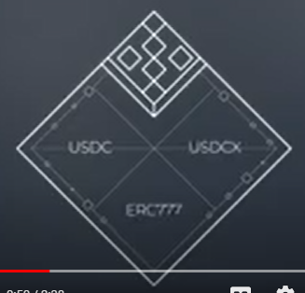

At 0:46, This scene could have been done showing a wrapping animation where you show a representation of USDC tokens getting “wrapped”, kinda like getting tucked into USDCx.

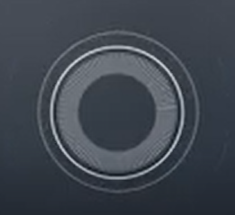

At 1:06, This radar animation doesn’t do the accumulating funds enough justice. It looks like some kind of radar/sonar thing. Perhaps you can take this icon below and show a shaded filling gradually rising from the bottom of the diamond to the top



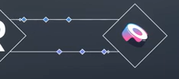

At 1:25, This Sushiswap interaction connection is not stream based, it occurs with periodic distributions. When it appears on this scene, it’s not explained and hence is confusing to the viewer. It’s probably worth removing it

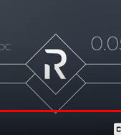

At 1:57, “on other decentralized exchanges”, might be worth flashing the Sushi logo or quickswap logo here.

Colors - could you make the colors in line with this pallette: <https://drive.google.com/file/d/1zi_B0ZNtj8nvbytTxSRcHO1YetqIb2d0/view?usp=sharing>

Would be nice to see some more of the ice blue and the background set to the navy we use on our website (<https://ricochet.exchange>)

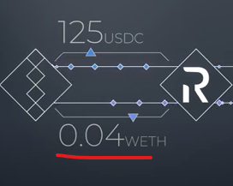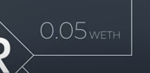

At 1:29, Might be worth flashing underneath here “= 100 USDC” in subtle font when the narrator says “worth 100 USDC” as well as at 2:03

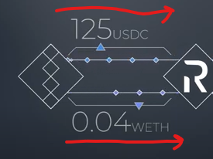

Both the USDC and WETH streams should be moving from user icon to Ricochet icon (remember market is 2-way and accepts both inputs)